Visualize data with

QuickSight

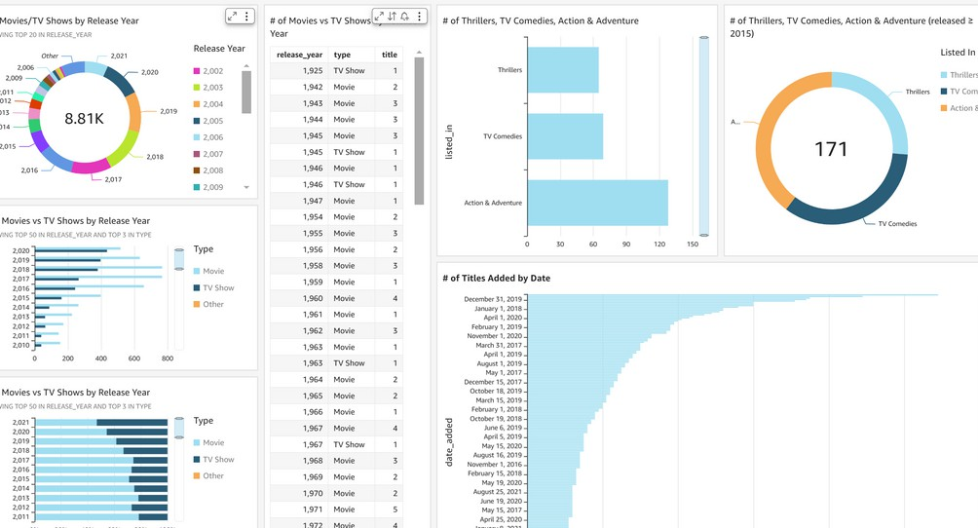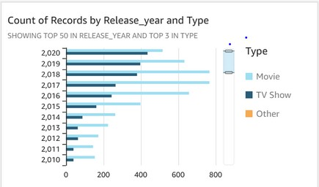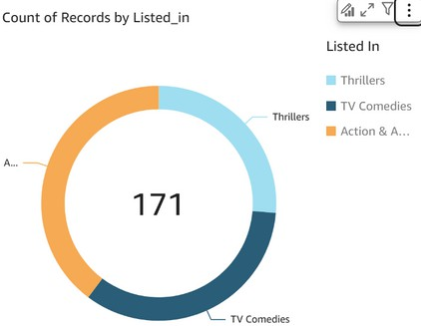

[bhagatanand28@gmail.com](mailto:bhagatanand28@gmail.com)

# Introducing Today's Project!

## What is Amazon QuickSight?

AmazonQuickSight is a cloud-powered business intelligence (BI) tool from AWS (Amazon Web Services) designed to enable users to create and share data visualizations and perform advanced analytics on various datasets.

## How I used Amazon QuickSight in this project

Today, I used Amazon QuickSight to integrate data from S3 andRDS, cleanand transform it, and build interactive dashboards with charts tracking key metrics. Using its ML insights, I identified anomalies and trends, then shared the dashboards.

## One thing I didn't expect in this project was...

One unexpected challenge in this project was dealing with data refresh delays

in Amazon QuickSight. I anticipated real-time updates, but larger datasets took longer to refresh, slightly impacting analysis speed.

Project timeframe : 3 hours

[bhagatanand28@gmail.com](mailto:bhagatanand28@gmail.com)

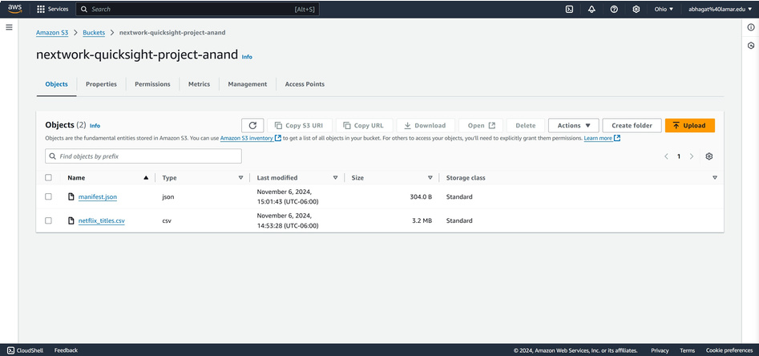

Upload project files into S3

S3 is used in this project to store dataset and manifest.json file.

I edited the manifest.json file by updating the S3 URL of my dataset. It's important to edit this file because keeping an outdated S3 URL means that manifest.json would be directing to the wrong address.

[bhagatanand28@gmail.com](mailto:bhagatanand28@gmail.com)

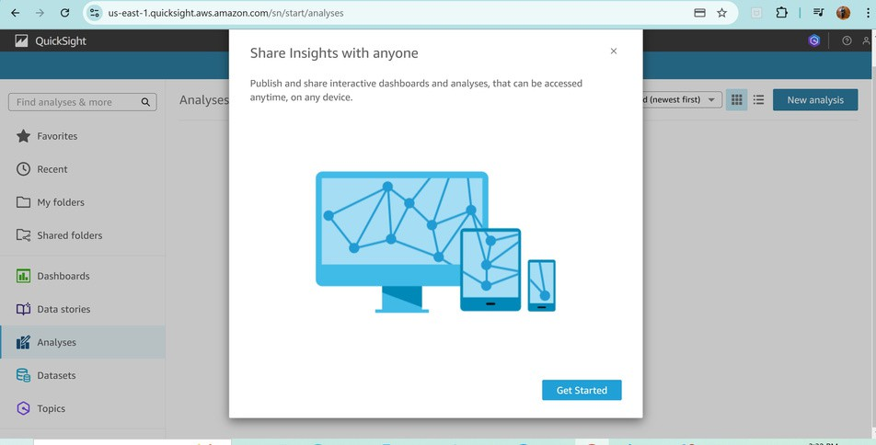

# Create QuickSight account

It is free to open a QuickSight account (the free trial last for 30 days).

It took two minutes to set up and wait for the account creation. I also had to enable QuickSight access to S3 because my dataset is stored in an S3 bucket, and specific access to the bucket is required for QuickSight to process the data.

[bhagatanand28@gmail.com](mailto:bhagatanand28@gmail.com)

# Download the Dataset

I connected the S3 bucket to QuickSight by visiting the Manage Data Sources page in QuickSight, where I selected New Data Set and chose S3 as the data source to specify the bucket and permissions.

The manifest.json file was important in this step because it provides QuickSight with the necessary information about the structure and location of the dataset stored in the S3 bucket.

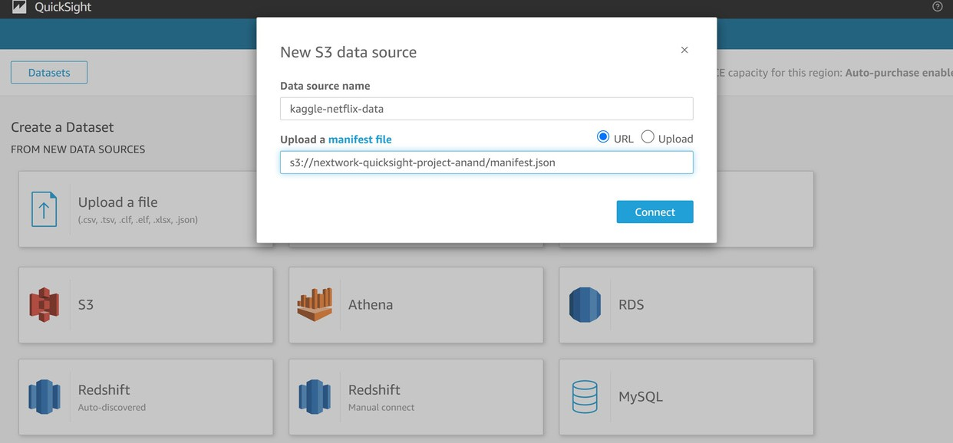

[bhagatanand28@gmail.com](mailto:bhagatanand28@gmail.com)

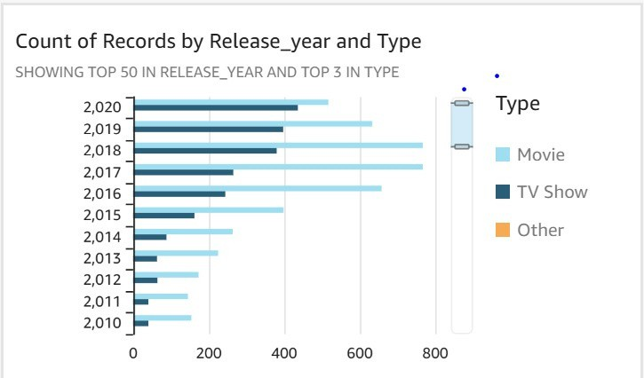

# My first visualization

To create visualizations on QuickSight, You have to drag relevant fields in to QuickSight Dashboard's AutoGraph Space.

The graph shown here is a breakdown of movies and Tv shows for every release year.

I created the graph by putting the release year on the Y-axis, and making the type ( i.e movies or Tv shows) the grouping variable.

[bhagatanand28@gmail.com](mailto:bhagatanand28@gmail.com)

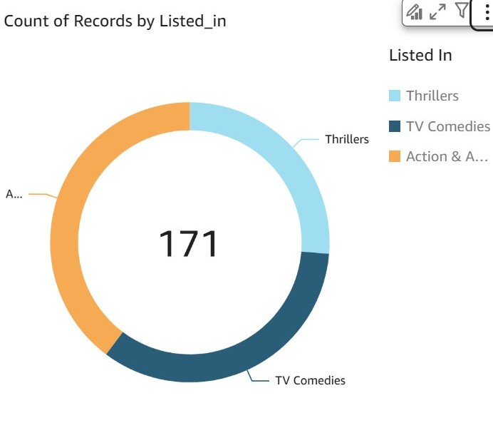

# Using filters

Filters are used to specify the exact set of data that you want to analyze, effectively excluding any irrelevant data.

Here, I added a filter by excluding movies and TV shows that were released before

2015. This helped create visualizations for movies and TV shows from the three genres I specified, focusing on those released in 2015 and onwards

[bhagatanand28@gmail.com](mailto:bhagatanand28@gmail.com)

# Setting up a dashboard

As a finishing touch, I edited the titles of my graphs so that the purpose of each chart is clear to the reader

I did this by publishing my dashboard and using the export function.

